enquiries refer

**Rob van Iersel**

in reply please quote: 21/

3 December 2021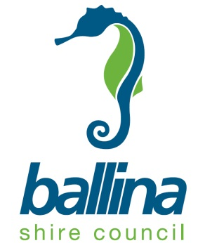

Addressee1

Addressee2

Addressee3

TOWN STATE PCODE

Dear Sir / Madam

Re: Public Exhibition of Rezoning Proposal from R2 Low Density to R3 Medium Density, Alstonville

At the Ordinary Council meeting of 28 October 2021, Council resolved to support a proposal to rezone land at Alstonville from R2 Low Density Residential to R3 Medium Density. The rezoning proposal applies to 64 individual lots in Daley Street, The Avenue, Coral Street and Wardell Road, located in easy walking distance to the Alstonville Village Centre, as per attached site map.

The rezoning is a recommendation in the Alstonville Strategic Plan as a way to provide new housing opportunities that promote affordability and provide choice for people to meet changing life needs.

The land use tables for both the R2 Low Density Residential Zone and the R3 Medium Density Residential Zone are enclosed. The R3 zone will permit a broader range of housing options for the land.

A Planning Proposal (BSCPP 21/003) describing the rezoning is currently on public exhibition, including appendix documents providing a range of additional information, including a local heritage study of the area.

Given the Christmas holiday period will occur during public exhibition of the proposal from **8 December 2021,** it will be extended to **2 February 2022.** The proposal is displayedat Council’s Customer Service Centre located at 40 Cherry Street, Ballina and may be inspected between 8.15am and 4.30pm Monday to Friday. It is also available for viewing at Council’s Community Access Points – Alstonville Library and on Council’s website; [www.ballina.nsw.gov.au](http://www.ballina.nsw.gov.au) under ‘Noticeboard – Documents on Exhibition’.

Council has been given delegation by the Department of Planning, Industry and Environment to undertake the processes for finalisation of the planning proposal (should it proceed to completion).

Written submissions in relation to the proposal are invited and may be addressed to the General Manager, Ballina Shire Council, PO Box 450, Ballina NSW 2478 or by email to [council@ballina.nsw.gov.au](mailto:council@ballina.nsw.gov.au). Please note that submissions close on **2 February 2022.**

Further information regarding public submissions and public disclosure requirements is provided on the following page. If you have any enquiries in regard to this matter please contact Strategic Planning on 1300 864 444 or email [strategic@ballina.nsw.gov.au](mailto:strategic@ballina.nsw.gov.au).

Yours faithfully

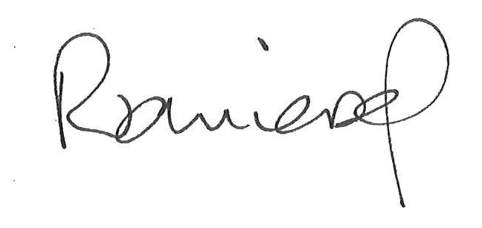

Robert van Iersel

Strategic Planner

Planning and Environmental Health Division

**Public Submissions**

Any person may make a submission in writing to Council.

Where a submission is by way of objection the grounds of objection must be specified in the submission.

All submissions, including any personal information contained therein, will become publicly available documents and will be made available to the applicant and any other interested members of the public.

They may also be included in Council’s business paper.

If you do not wish your submission to be publicly available you must provide Council with written reasons for this.

Alternatively, you may wish to provide an anonymous submission. However, anonymous submissions may be given less (or no) weight in the overall consideration of the proposal.

**For more information on preparing any submission or how Council manages your submission, refer to our website *ballina.nsw.gov.au (search “your privacy”).***

**Public Disclosure**

A person making the submission or any associate of that person, within the period commencing two years before the submission is made and ending when the application is determined, is required to disclose:

* All reportable political donations made to any local Councillor of that Council; and
* All gifts made to any local Councillor or employee of that Council.

A reference to a reportable political donation made to a "local Councillor" includes a reference to a donation made at the time the person was a candidate for election to the Council.

Significant penalties apply to non-disclosure. For more information and to obtain a political donations and gifts disclosure statement go to the Department of Planning & Environment website at ***planning.nsw.gov.au***

Site Map



**Figure 1 – Site Identification Diagram showing area subject to planning proposal**





